**Project Design Phase-I**

**Solution Architecture**

|  |  |
| --- | --- |
| Date | 19 September 2022 |
| Team ID | PNT2022TMID12518 |
| Project Name | Project - Nutrition Assistant Application |
| Maximum Marks | 4 Marks |

**Solution Architecture:**

Solution architecture has several sub processes such as to collect the image of the food from the user, send the image to the server, access nutrition API, get food attributes and report to the user.

There are applications that suggest meal plan for the required calories. Such applications are useful when an individual plans in advance to cook and take. However most of the time people tend to eat food from various places. Hence there is a requirement to estimate the food nutrient value instantly and easily.

The proposed solution captures the image of the food, sends the image to the server. Using Nutrition API, the application will get the estimate of the nutrient value of the food. These values are stored in database. The estimate is presented to the user.

The design phase of the project is modularized to undertake each of the listed goals. The presented solution will be implemented, tested and will be delivered for use by the customers.

**Solution Architecture Diagram:**

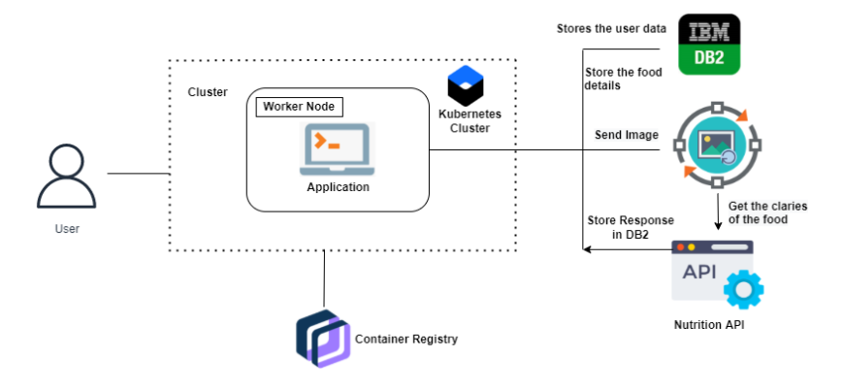

Figure 1: Architecture and data flow of the Nutrition Assistant Application

**Reference:** Ahn Jeong Sun, Kim Dong Woo, Kim Jiae, Park Haemin, Lee Jung Eun, "Development of a Smartphone Application for Dietary Self-Monitoring", Frontiers in Nutrition, Vol 6, 2019